Constructing Ring

Definition
# Source: AI Source: Provided by: [Data Path: Persons Table -> ID Column: 1, Name_En Column: Motasem Essam] -> From: [ChatGPT] on [7/25/2026]
Constructing a Ring is the process of creating a circular region bounded by two concentric circles, producing a shape with a circular hole in the center.
In geometry, the precise term for this shape is an annular region or annulus.
A ring consists of:
- An outer circle with radius $R$.
- An inner circle with radius $r$.
- A common center $O$.
- The region between the two circles.
$$\boxed{R>r>0}$$
The two circles are concentric because they have the same center.

Fundamental Concept
# Source: AI Source: Provided by: [Data Path: Persons Table -> ID Column: 1, Name_En Column: Motasem Essam] -> From: [ChatGPT] on [7/25/2026]
A ring is formed by removing the interior of a smaller circle from a larger circle with the same center.
$$\boxed{\text{Ring}=\text{Outer Circular Region}-\text{Inner Circular Region}}$$
If the outer radius is $R$and the inner radius is $r$, the ring is:
$$\boxed{r≤OP≤R}$$
where $P$is any point in the ring and $O$is the common center.

Main Construction

Constructing a Ring From Two Radii
# Source: AI Source: Provided by: [Data Path: Persons Table -> ID Column: 1, Name_En Column: Motasem Essam] -> From: [ChatGPT] on [7/25/2026]
Given
- Center $O$
- Outer radius $R$
- Inner radius $r$
where:
$$R>r$$
Steps
- Mark the center $O$.
- Set the compass to the outer radius $R$.
- Draw the outer circle centered at $O$.
- Set the compass to the inner radius $r$.
- Without changing the center $O$, draw the inner circle.
- The region between the two concentric circles is the ring.
The result is:
$$\boxed{\text{Ring}=C\left(O , R\right)∖Interior⁡\left(C\left(O , r\right)\right)}$$

Construction From Outer and Inner Diameters
# Source: AI Source: Provided by: [Data Path: Persons Table -> ID Column: 1, Name_En Column: Motasem Essam] -> From: [ChatGPT] on [7/25/2026]
If the given information consists of diameters:
$$D=2R$$
and:
$$d=2r$$
then:
$$\boxed{R=\frac{D}{2}}$$
and:
$$\boxed{r=\frac{d}{2}}$$
Construction
- Find the common center $O$.
- Construct the outer circle with radius $D/2$.
- Construct the inner circle with radius $d/2$.
- Keep the same center for both circles.
- The region between them forms the ring.

Construction From Ring Thickness
# Source: AI Source: Provided by: [Data Path: Persons Table -> ID Column: 1, Name_En Column: Motasem Essam] -> From: [ChatGPT] on [7/25/2026]
Sometimes the outer radius and the thickness of the ring are given.
Let:
$$t=R-r$$
Therefore:
$$\boxed{r=R-t}$$
Steps
- Construct the outer circle with radius $R$.
- Calculate or construct the inner radius:
$$r=R-t$$
- Using the same center, construct the inner circle.
- The region between the circles is the ring.
The thickness is constant everywhere:
$$\boxed{t=R-r}$$

Construction From Inner Radius and Thickness
# Source: AI Source: Provided by: [Data Path: Persons Table -> ID Column: 1, Name_En Column: Motasem Essam] -> From: [ChatGPT] on [7/25/2026]
If the inner radius $r$and ring thickness $t$are known:
$$\boxed{R=r+t}$$
Construction
- Construct the inner circle with radius $r$.
- Keep the same center.
- Increase the compass opening by $t$.
- Construct the outer circle.
- The region between the circles is the ring.

Mathematical Representation
# Source: AI Source: Provided by: [Data Path: Persons Table -> ID Column: 1, Name_En Column: Motasem Essam] -> From: [ChatGPT] on [7/25/2026]
Let the common center be:
$$O=\left(h , k\right)$$
The outer circle is:
$$\boxed{{\left(x-h\right)}^{2}+{\left(y-k\right)}^{2}=R^{2}}$$
The inner circle is:
$$\boxed{{\left(x-h\right)}^{2}+{\left(y-k\right)}^{2}=r^{2}}$$
The annular region between them is represented by:
$$\boxed{r^{2}≤{\left(x-h\right)}^{2}+{\left(y-k\right)}^{2}≤R^{2}}$$

Important Elements
# Source: AI Source: Provided by: [Data Path: Persons Table -> ID Column: 1, Name_En Column: Motasem Essam] -> From: [ChatGPT] on [7/25/2026]
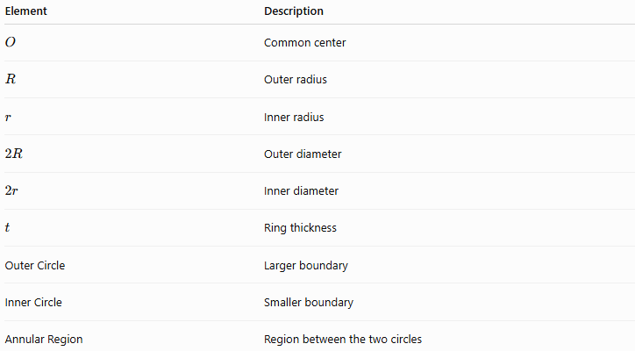
Element | Description
$$O$$ | Common center
$$R$$ | Outer radius
$$r$$ | Inner radius
$$2R$$ | Outer diameter
$$2r$$ | Inner diameter
$$t$$ | Ring thickness
Outer Circle | Larger boundary
Inner Circle | Smaller boundary
Annular Region | Region between the two circles
The fundamental relationship is:
$$\boxed{t=R-r}$$

Area of a Ring
# Source: AI Source: Provided by: [Data Path: Persons Table -> ID Column: 1, Name_En Column: Motasem Essam] -> From: [ChatGPT] on [7/25/2026]
The area is the area of the outer circular region minus the area of the inner circular region:
$$A=πR^{2}-πr^{2}$$
Therefore:
$$\boxed{A=π\left(R^{2}-r^{2}\right)}$$
Using the difference of squares:
$$\boxed{A=π\left(R-r\right)\left(R+r\right)}$$
Since:
$$t=R-r$$
we can also write:
$$\boxed{A=πt\left(R+r\right)}$$

Perimeter of a Ring
# Source: AI Source: Provided by: [Data Path: Persons Table -> ID Column: 1, Name_En Column: Motasem Essam] -> From: [ChatGPT] on [7/25/2026]
The boundary consists of two circles.
Outer circumference
$$C_{o}=2πR$$
Inner circumference
$$C_{i}=2πr$$
Therefore, the total boundary length is:
$$\boxed{P=2πR+2πr}$$
or:
$$\boxed{P=2π\left(R+r\right)}$$

Types of Ring Construction
# Source: AI Source: Provided by: [Data Path: Persons Table -> ID Column: 1, Name_En Column: Motasem Essam] -> From: [ChatGPT] on [7/25/2026]
The following are construction situations, rather than universally standardized mathematical types of rings.
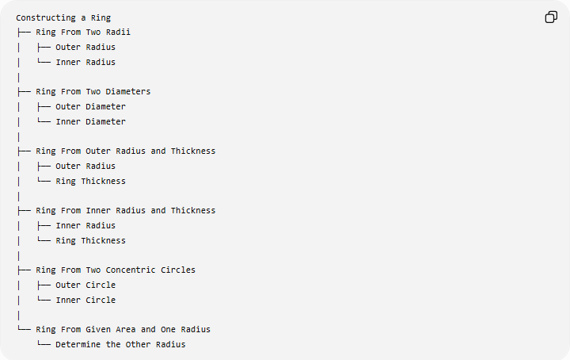
Constructing a Ring
├── Ring From Two Radii
│ ├── Outer Radius
│ └── Inner Radius
│
├── Ring From Two Diameters
│ ├── Outer Diameter
│ └── Inner Diameter
│
├── Ring From Outer Radius and Thickness
│ ├── Outer Radius
│ └── Ring Thickness
│
├── Ring From Inner Radius and Thickness
│ ├── Inner Radius
│ └── Ring Thickness
│
├── Ring From Two Concentric Circles
│ ├── Outer Circle
│ └── Inner Circle
│
└── Ring From Given Area and One Radius
└── Determine the Other Radius

Basic Constructions Used
# Source: AI Source: Provided by: [Data Path: Persons Table -> ID Column: 1, Name_En Column: Motasem Essam] -> From: [ChatGPT] on [7/25/2026]
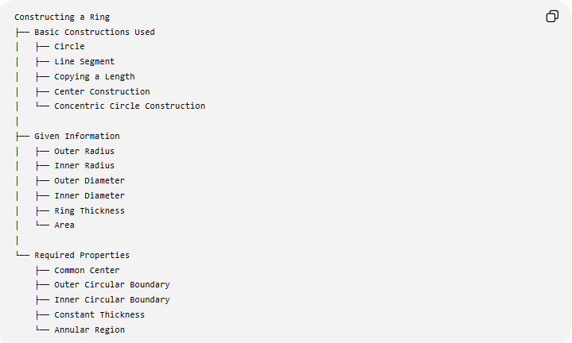
Constructing a Ring
├── Basic Constructions Used
│ ├── Circle
│ ├── Line Segment
│ ├── Copying a Length
│ ├── Center Construction
│ └── Concentric Circle Construction
│
├── Given Information
│ ├── Outer Radius
│ ├── Inner Radius
│ ├── Outer Diameter
│ ├── Inner Diameter
│ ├── Ring Thickness
│ └── Area
│
└── Required Properties
├── Common Center
├── Outer Circular Boundary
├── Inner Circular Boundary
├── Constant Thickness
└── Annular Region

Ring Thickness
# Source: AI Source: Provided by: [Data Path: Persons Table -> ID Column: 1, Name_En Column: Motasem Essam] -> From: [ChatGPT] on [7/25/2026]
A fundamental property of a ring is that its radial thickness is constant.
For any radius measured from the center:
$$\boxed{t=R-r}$$
For example, if:
$$R=10\text{ cm}$$
and:
$$r=6\text{ cm}$$
then:
$$t=10-6 \\ \boxed{t=4\text{ cm}}$$

Example
# Source: AI Source: Provided by: [Data Path: Persons Table -> ID Column: 1, Name_En Column: Motasem Essam] -> From: [ChatGPT] on [7/25/2026]
Suppose a ring has:
$$R=8\text{ cm}$$
and:
$$r=5\text{ cm}$$
Thickness
$$t=R-r \\ t=8-5 \\ \boxed{t=3\text{ cm}}$$
Area
$$A=π\left(R^{2}-r^{2}\right) \\ A=π\left(8^{2}-5^{2}\right) \\ A=π\left(64-25\right) \\ \boxed{A=39π{\text{ cm}}^{2}}$$
Total Boundary Length
$$P=2π\left(R+r\right) \\ P=2π\left(8+5\right) \\ \boxed{P=26π\text{ cm}}$$

Ring vs Circle vs Circular Region
# Source: AI Source: Provided by: [Data Path: Persons Table -> ID Column: 1, Name_En Column: Motasem Essam] -> From: [ChatGPT] on [7/25/2026]
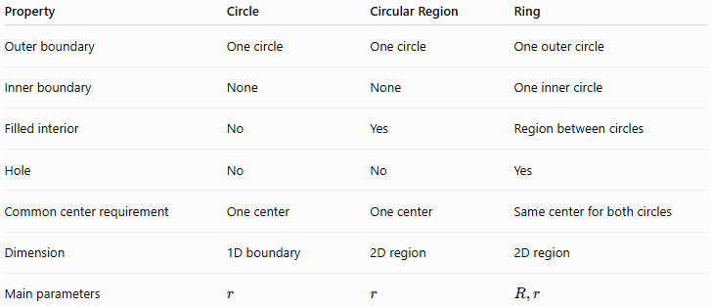
Property | Circle | Circular Region | Ring
Outer boundary | One circle | One circle | One outer circle
Inner boundary | None | None | One inner circle
Filled interior | No | Yes | Region between circles
Hole | No | No | Yes
Common center requirement | One center | One center | Same center for both circles
Dimension | 1D boundary | 2D region | 2D region
Main parameters | $$r$$ | $$r$$ | $$R,r$$
A circle is only the boundary:
$$\boxed{{\left(x-h\right)}^{2}+{\left(y-k\right)}^{2}=r^{2}}$$
A circular region includes its interior:
$$\boxed{{\left(x-h\right)}^{2}+{\left(y-k\right)}^{2}≤r^{2}}$$
A ring contains the region between two concentric circles:
$$\boxed{r^{2}≤{\left(x-h\right)}^{2}+{\left(y-k\right)}^{2}≤R^{2}}$$

Ring vs Annulus
# Source: AI Source: Provided by: [Data Path: Persons Table -> ID Column: 1, Name_En Column: Motasem Essam] -> From: [ChatGPT] on [7/25/2026]
In precise mathematical terminology:
$$\boxed{\text{Ring}≈\text{Annular Region}}$$
Annulus is the standard mathematical term for the region between two concentric circles.
Ring is a broader and more informal term commonly used for the same shape.
The term annular region emphasizes that the object is a 2D region, not merely the two circular boundaries.

Related Constructions
# Source: AI Source: Provided by: [Data Path: Persons Table -> ID Column: 1, Name_En Column: Motasem Essam] -> From: [ChatGPT] on [7/25/2026]
Annular Sector
A ring can be restricted to a particular central angle to form an annular sector.
It is bounded by:
- an outer circular arc,
- an inner circular arc,
- two radial segments.
For angle $θ$in radians:
$$\boxed{A=\frac{1}{2}θ\left(R^{2}-r^{2}\right)}$$

Circular Ring With a Sector Removed
# Source: AI Source: Provided by: [Data Path: Persons Table -> ID Column: 1, Name_En Column: Motasem Essam] -> From: [ChatGPT] on [7/25/2026]
A complete ring can be divided into several equal sections by constructing radii from the common center.
For $n$equal sections:
$$\boxed{θ=\frac{{360}^{∘}}{n}}$$
Each section is an annular sector.

Special Cases
# Source: AI Source: Provided by: [Data Path: Persons Table -> ID Column: 1, Name_En Column: Motasem Essam] -> From: [ChatGPT] on [7/25/2026]
$$r=0$$
If:
$$r=0$$
the inner hole disappears, and the ring becomes a circular region:
$$A=πR^{2}$$
$$r=R$$
If:
$$r=R$$
then:
$$A=0$$
so there is no area between the two boundaries.
Therefore, for a non-degenerate ring:
$$\boxed{R>r>0}$$

Construction Tools
# Source: AI Source: Provided by: [Data Path: Persons Table -> ID Column: 1, Name_En Column: Motasem Essam] -> From: [ChatGPT] on [7/25/2026]
The primary tools are:
- Compass — constructs the two concentric circles.
- Straightedge — constructs the center, radii, diameters, and auxiliary lines.
- Ruler — may be used when numerical measurements are allowed.
The essential construction principle is:
$$\boxed{\text{Same Center}+\text{Two Different Radii}}$$

Classification Within Geometric Construction
# Source: AI Source: Provided by: [Data Path: Persons Table -> ID Column: 1, Name_En Column: Motasem Essam] -> From: [ChatGPT] on [7/25/2026]
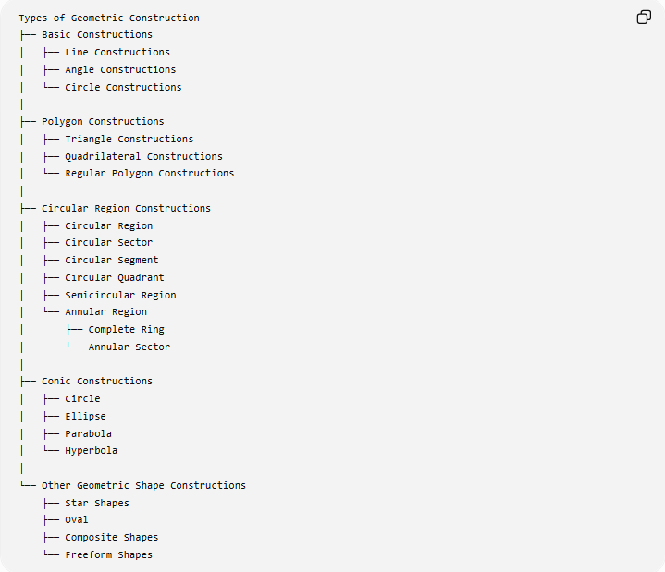
Types of Geometric Construction
├── Basic Constructions
│ ├── Line Constructions
│ ├── Angle Constructions
│ └── Circle Constructions
│
├── Polygon Constructions
│ ├── Triangle Constructions
│ ├── Quadrilateral Constructions
│ └── Regular Polygon Constructions
│
├── Circular Region Constructions
│ ├── Circular Region
│ ├── Circular Sector
│ ├── Circular Segment
│ ├── Circular Quadrant
│ ├── Semicircular Region
│ └── Annular Region
│ ├── Complete Ring
│ └── Annular Sector
│
├── Conic Constructions
│ ├── Circle
│ ├── Ellipse
│ ├── Parabola
│ └── Hyperbola
│
└── Other Geometric Shape Constructions
├── Star Shapes
├── Oval
├── Composite Shapes
└── Freeform Shapes
Classification note: Ring is a descriptive/common name. The mathematically precise category is annular region (or annulus). It belongs with circular-region constructions rather than being classified as a separate conic.

Key Points
# Source: AI Source: Provided by: [Data Path: Persons Table -> ID Column: 1, Name_En Column: Motasem Essam] -> From: [ChatGPT] on [7/25/2026]
- A ring is the region between two concentric circles.
- The precise mathematical term is annular region or annulus.
- Both circles have the same center:
$$\boxed{O_{\text{outer}}=O_{\text{inner}}}$$
- The outer radius must be greater than the inner radius:
$$\boxed{R>r>0}$$
- Ring thickness:
$$\boxed{t=R-r}$$
- Ring area:
$$\boxed{A=π\left(R^{2}-r^{2}\right)}$$
- Total boundary length:
$$\boxed{P=2π\left(R+r\right)}$$
- A ring can be constructed simply by drawing two concentric circles with different radii.
- A partial ring bounded by two radii is an annular sector.

Conclusion
# Source: AI Source: Provided by: [Data Path: Persons Table -> ID Column: 1, Name_En Column: Motasem Essam] -> From: [ChatGPT] on [7/25/2026]
Constructing a Ring consists fundamentally of constructing two concentric circles with different radii and taking the region between them. The outer circle determines the outside boundary, the inner circle determines the hole, and the difference between their radii determines the constant thickness. In mathematical terminology, this region is an annular region (annulus).

